INTRODUCTION:
The Atterberg limits are a basic measure of the nature of a fine-grained soil. Depending on the water content of the soil, it may appear in four states: solid, semi-solid, plastic and liquid. In each state the consistency and behavior of a soil is different and thus so are its engineering properties. Thus, the boundary between each state can be defined based on a change in the soil's behavior. The Atterberg limits can be used to distinguish between silt and clay, and it can distinguish between different types of silts and clays. These limits were created by Albert Atterberg, a Swedish chemist.^{[1]} They were later refined by Arthur Casagrande.

OBJECTIVE:
To determine the liquid and plastic limits of the given soil sample.

THEORY:
The definitions of the consistency limits proposed by Atterberg are not, by themselves, adequate for the determination of their numerical values in the laboratory, especially in view of the arbitrary nature of these definitions. In view of this, Arthur Casagrade and others suggested more practical definitions with special reference to the laboratory devices and methods developed for the purpose of the determination of the consistency limits. In this sub-section, the laboratory methods for determination of the liquid limit, plastic limit, shrinkage limit, and other related concepts and indices will be studied, as standardized and accepted by the Indian Standard Institution and incorporated in the codes or practice.

Shrinkage limit:
The shrinkage limit (SL) is the water content where further loss of moisture will not result in any more volume reduction. The shrinkage limit is much less commonly used than the liquid limit and the plastic limit.
Plastic limit:
The plastic limit (PL) is the water content where soil starts to exhibit plastic behavior. A thread of soil is at its plastic limit when it is rolled to a diameter of 3 mm or begins to crumble. To improve consistency, a 3 mm diameter rod is often used to gauge the thickness of the thread when conducting the test. (AKA Soil Snake Test).
Liquid limit:
‘Liquid limit’ (LL or ) is defined as the arbitrary limit of water content at which the soil is just about to pass from the plastic state into the liquid state. At this limit, the soil possesses a small value of shear strength, losing its ability to flow as a liquid.In other words, the liquid limit is the minimum moisture content at which the soil tends to flow as a liquid.

TERMS:
PLATICITY INDEX:
‘Plasticity index’ (PI or ) is the range of water content within which the soil exhibits plastic properties; that is, it is the difference between liquid and plastic limits.
PI (or ) = (LL - PL) = ()
When the plastic limit cannot be determined, the material is said to be non-plastic (NP).
Plasticity index for sands is zero.
For proper evaluation of the plasticity properties of a soil, it has been found desirable to
use both the liquid limit and the plasticity index values.

SHRINKAGE INDEX:
‘Shrinkage index’ (SI OR ) is defined as the difference between the plastic and shrinkage limits of a soil; in other words, it is the range of water content within which a soil is in a semisolid state of consistency.
SI (or ) = (SL OR ) = ()

CONSISTENCY INDEX:
‘Consistency index’ or ‘Relative consistency’ (CI OR ) is defined as the ratio of the difference between liquid limit and the natural water content to the plasticity index of a soil:
CI OR = (LL - w) / PI = () /

Where w = natural water content of the soil (water content of a soil in the undisturbed condition in the ground).
If = 0, w = LL
= 1, w = PL
> 1, the soil is in semi-solid state and is stiff.
< 0, the natural water content is greater than LL, and the soil behaves like a liquid.

LIQUIDITY INDEX:
‘Liquidity index (LI OR IL) or ‘Water-plasticity ratio’ is the ratio of the difference between the natural water content and the plastic limit to the plasticity index:
LI or () = (w - PL) / PI or () = ( w - /
If = 0, w = PL
= 1, w = LL
> 1, the soil is in liquid state.
< 0, the soil is in semi-solid state and is stiff.

Obviously, CI + LI = 1

APPARATUS:
- FOR LIQUID LIMIT DETERMINATION:
The apparatus required are the mechanical liquid limit device, grooving tool, porcelain evaporating dish, flat glass plate, spatula, palette knives, balance, oven wash bottle with distilled water and containers.

- FOR PLASTIC LIMIT DETERMINATION:

The apparatus consists of a porcelain evaporating dish, about 12 cm in diameter (or a flat glass plate, 10 mm thick and about 45 cm square), spatula, about 8 cm long and 2 cm wide (or palette knives, with the blade about 20 cm long and 3 cm wide, for use with flat glass plate for mixing soil and water), a ground-glass plate, about 20×15 cm, for a surface for rolling, balance, oven, containers, and a rod, 3 mm in diameter and about 10 cm long.

STANDARD REFERENCE:

FOR LIQUID LIMIT:

The liquid limit is determined in the laboratory with the aid of the standard mechanical liquid limit device, designed by Arthur Casagrande and adopted by the ISI, as given in IS:2720(Part V)–1985.

FOR PLASTIC LIMIT:

IS: 2720, Part V–1985.

FIGURES:-
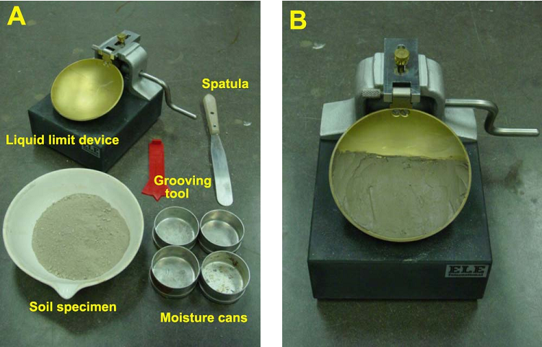
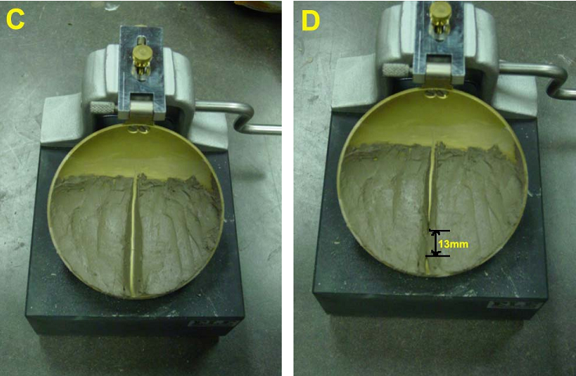
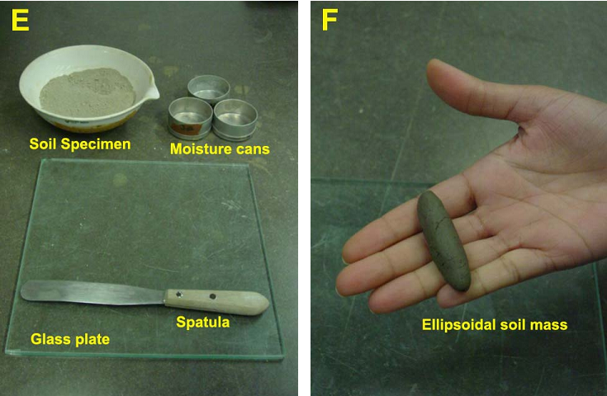
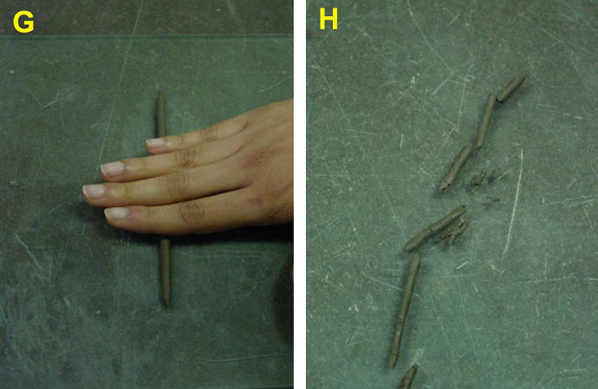
TEST PROCEDURE:-
Liquid Limit:
- Take roughly 3/4 of the soil and place it into the porcelain dish. Assume that the soil was previously passed though a No. 40 sieve, air-dried, and then pulverized. Thoroughly mix the soil with a small amount of distilled water until it appears as a smooth uniform paste. Cover the dish with cellophane to prevent moisture from escaping.
- Weigh four of the empty moisture cans with their lids, and record the respective weights and can numbers on the data sheet.
- Adjust the liquid limit apparatus by checking the height of drop of the cup. The point on the cup that comes in contact with the base should rise to a height of 10 mm. The block on the end of the grooving tool is 10 mm high and should be used as a gage. Practice using the cup and determine the correct rate to rotate the crank so that the cup drops approximately two times per second.
- Place a portion of the previously mixed soil into the cup of the liquid limit apparatus at the point where the cup rests on the base. Squeeze the soil down to eliminate air pockets and spread it into the cup to a depth of about 10 mm at its deepest point. The soil pat should form an approximately horizontal surface (See Photo B).
- Use the grooving tool carefully cut a clean straight groove down the center of the cup. The tool should remain perpendicular to the surface of the cup as groove is being made. Use extreme care to prevent sliding the soil relative to the surface of the cup (See Photo C).
- Make sure that the base of the apparatus below the cup and the underside of the cup is clean of soil. Turn the crank of the apparatus at a rate of approximately two drops per second and count the number of drops, N, it takes to make the two halves of the soil pat come into contact at the bottom of the groove along a distance of 13 mm (1/2 in.) (See Photo D). If the number of drops exceeds 50, then go directly to step eight and do not record the number of drops, otherwise, record the number of drops on the data sheet.
- Take a sample, using the spatula, from edge to edge of the soil pat. The sample should include the soil on both sides of where the groove came into contact. Place the soil into a moisture can cover it. Immediately weigh the moisture can containing the soil, record its mass, remove the lid, and place the can into the oven. Leave the moisture can in the oven for at least 16 hours. Place the soil remaining in the cup into the porcelain dish. Clean and dry the cup on the apparatus and the grooving tool.
- Remix the entire soil specimen in the porcelain dish. Add a small amount of distilled water to increase the water content so that the number of drops required to close the groove decrease.
- Repeat steps six, seven, and eight for at least two additional trials producing successively lower numbers of drops to close the groove. One of the trials shall be for a closure requiring 25 to 35 drops, one for closure between 20 and 30 drops, and one trial for a closure requiring 15 to 25 drops. Determine the water content from each trial by using the same method used in the first laboratory. Remember to use the same balance for all weighing.
Plastic Limit:
- Weigh the remaining empty moisture cans with their lids, and record the respective weights and can numbers on the data sheet.
- Take the remaining 1/4 of the original soil sample and add distilled water until the soil is at a consistency where it can be rolled without sticking to the hands.
- Form the soil into an ellipsoidal mass (See Photo F). Roll the mass between the palm or the fingers and the glass plate (See Photo G). Use sufficient pressure to roll the mass into a thread of uniform diameter by using about 90 strokes per minute. (A stroke is one complete motion of the hand forward and back to the starting position.) The thread shall be deformed so that its diameter reaches 3.2 mm (1/8 in.), taking no more than two minutes.
- When the diameter of the thread reaches the correct diameter, break the thread into several pieces. Knead and reform the pieces into ellipsoidal masses and re-roll them. Continue this alternate rolling, gathering together, kneading and re-rolling until the thread crumbles under the pressure required for rolling and can no longer be rolled into a 3.2 mm diameter thread (See Photo H).
- Gather the portions of the crumbled thread together and place the soil into a moisture can, then cover it. If the can does not contain at least 6 grams of soil, add soil to the can from the next trial (See Step 6). Immediately weigh the moisture can containing the soil, record its mass, remove the lid, and place the can into the oven. Leave the moisture can in the oven for at least 16 hours.
- Repeat steps three, four, and five at least two more times. Determine the water content from each trial by using the same method used in the first laboratory. Remember to use the same balance for all weighing.

Different Classification Systems Followed in Classification of Soils:
FOR ENGINEERING PURPOSE:
Engineers, typically Geotechnical engineers, classify soils according to their engineering properties as they relate to use for foundation support or building material. Modern engineering classification systems are designed to allow an easy transition from field observations to basic predictions of soil engineering properties and behaviors.
The most common engineering classification system for soils in North America is the Unified Soil Classification System (USCS). The USCS has three major classification groups:
- Coarse-grained soil (e.g. sands and gravels).
- Fine-grained soils (e.g. silts and clays).
- Highly organic soils (mainly referred to as “peat”).
The USCS further subdivides the three major soil classes for clarification.
Other engineering soil classification systems in the States include the AASHTO Soil Classification System and the Modified Burmister A full geotechnical engineering soil description will also include other properties of the soil including color, in-situ moisture content, in-situ strength, and somewhat more detail about the material properties of the soil than is provided by the USCS code.

SOIL SCIENCE:
For soil resources, experience has shown that a natural system approach to classification, i.e. grouping soils by their intrinsic property (soil morphology), behaviour, or genesis, results in classes that can be interpreted for many diverse uses. Differing concepts of pedogenesis, and differences in the significance of morphological features to various land uses can affect the classification approach. Despite these differences, in a well-constructed system, classification criteria group similar concepts so that interpretations do not vary widely. This is in contrast to a technical system approach to soil classification, where soils are grouped according to their fitness for a specific use and theiredaphic characteristics.
Natural system approaches to soil classification, such as the French Soil Reference System (Référentiel pédologique français) are based on presumed soil genesis. Systems have developed, such as USDA soil taxonomy and the World Reference Base for Soil Resources, which use taxonomic criteria involving soil morphology and laboratory tests to inform and refine hierarchical classes.
Another approach is numerical classification, also called ordination, where soil individuals are grouped by multivariate statistical methods such as cluster analysis. This produces natural groupings without requiring any inference about soil genesis.
In soil survey, as practiced in the United States, soil classification usually means criteria based on soil morphology in addition to characteristics developed during soil formation. Criteria are designed to guide choices in land use and soil management. As indicated, this is a hierarchical system that is a hybrid of both natural and objective criteria. USDA soil taxonomy provides the core criteria for differentiating soil map units. This is a substantial revision of the 1938 USDA soil taxonomy which was a strictly natural system. Soil taxonomy based soil map units are additionally sorted into classes based on technical classification systems. Land Capability Classes, hydric soil, and prime farmland are some examples.
In addition to scientific soil classification systems, there are also vernacular soil classification systems. Folk taxonomies have been used for millennia, while scientifically based systems are relatively recent developments.

Example Data
Liquid Limit Determination

Sample No. | 1 | 2 | 3 | 4
Moisture can and lid number | A1 | A2 | A3 | A4
M_{c} = Mass of empty, clean can + lid (grams) | 22.23 | 23.31 | 21.87 | 22.58
M_{CMS} = Mass of can, lid, and moist soil (grams) | 28.56 | 29.27 | 25.73 | 25.22
M_{CDS} = Mass of can, lid, and dry soil (grams) | 27.40 | 28.10 | 24.90 | 24.60
M_{S} = Mass of soil solids (grams) | 5.03 | 4.79 | 3.03 | 2.02
M_{W} = Mass of pore water (grams) | 1.16 | 1.17 | 0.83 | 0.62
w = Water content, w% | 23.06 | 24.43 | 27.39 | 30.69
No. of drops (N) | 31 | 29 | 20 | 14

Plastic Limit Determination

Sample No. | 1 | 2 | 3
Moisture can and lid number | A6 | A7 | A8
M_{c} = Mass of empty, clean can + lid (grams) | 7.78 | 7.83 | 15.16
M_{CMS} = Mass of can, lid, and moist soil (grams) | 16.39 | 13.43 | 21.23
M_{CDS} = Mass of can, lid, and dry soil (grams) | 15.28 | 12.69 | 20.43
M_{S} = Mass of soil solids (grams) | 7.5 | 4.86 | 5.27
M_{W} = Mass of pore water (grams) | 1.11 | 0.74 | 0.8
w = Water content, w% | 14.8 | 15.2 | 15.1

Plastic Limit (PL)= Average w % = (14.8+15.2+15.1)/3 = 15.0

Liquid Limit Chart:

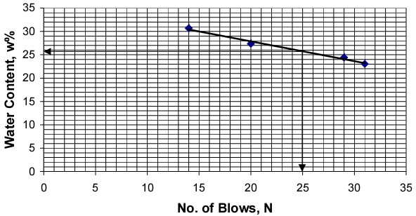

From the above graph, liquid limit = 26
Results:
Liquid Limit = 26 Plastic Limit = 15 Plasticity Index =11
OBSERVATION TABLE:-
Liquid Limit Determination

Sample No. | 1 | 2 | 3 | 4
Moisture can and lid number
M_{c} = Mass of empty, clean can + lid (grams)
M_{CMS} = Mass of can, lid, and moist soil (grams)
M_{CDS} = Mass of can, lid, and dry soil (grams)
M_{S} = Mass of soil solids (grams)
M_{W} = Mass of pore water (grams)
w = Water content, w%
No. of drops (N)

Plastic Limit Determination

Sample No. | 1 | 2 | 3
Moisture can and lid number
M_{c} = Mass of empty, clean can + lid (grams)
M_{CMS} = Mass of can, lid, and moist soil (grams)
M_{CDS} = Mass of can, lid, and dry soil (grams)
M_{S} = Mass of soil solids (grams)
M_{W} = Mass of pore water (grams)
w = Water content, w%

Liquid Limit =
Plastic Limit =
Plasticity Index =

QUIZ:
- What is liquid limit?
- What is plastic limit?
- What apparatus is used to measure the liquid limit of a given soil sample.
- What number of blows is taken for consideration while determining the liquid limit of a given soil sample.
- What is plasticity index?

Objective:
- Atterberg limits are usefull for
- Fine grained soil
- Coarse grained soil
- Both a and b
- None
- In liquid state the shear strength is
- Zero
- <0
- >0
- None
- If soft rubber base is used instead of standard rubber base, liquid limit of soil always -------because more number of blows are required
- Increases
- Decreases
- Remains same
- None
- Shrinkage ratio is given by
- ᵞd/ᵞw
- ᵞd/ᵞ
- ᵞw/ᵞd
- ᵞ/ᵞw
- Shrinkage limit is given by
- e/G
- ᵞd/ᵞw
- 1-e/G
- 1-ᵞd/ᵞw

- Plastic index is given by (Ip)
- Wl-Wp
- Ws-Wp
- Wp-Ws
- Wl-Ws
- Plasticity index of non plastic soil is
- =0
- <0
- >0
- None
- Toughness index is given as
- Plasticity index(Ip)/Flow index(If)
- If/Ip
- If/Is
- Ip/Is
- If consistency index is negative the soil will be in ---------- state
- Liquid
- Plastic
- Semisolid
- Solid
- Liquid limit, plastic limit and plasticity index ______ with _____ of grain size
- Decreases, Increases
- Decreases, Decreases
- Increases, Increases
- Increases, Decreases

REFERENCES:-
- IS : 2720 (Part II) – 1973, Method of Test for soil : Part II
- Soil Mechanics and Foundations.
- http://en.wikipedia.org/wiki/Atterberg_limits
- http://www.answers.com/topic/atterberg-limits
- http://www.tpub.com/content/engineering/14069/css/14069_543.htm
- http://www.civil.umaine.edu/cie366/atterberg_limits/default.htm
- A textbook on geotechnical engineering by C.Venkataramaiah.
- A textbook on geotechnical engineering by B.C.Punmia
- A textbook on geotechnical engineering by V.N.S.Murthy
- http://www.astm.org/Standards/D4318.htm
- http://www.aboutcivil.com/atterberg-limits.html
- http://en.wikipedia.org/wiki/Soil_classification.

PART – 2
ANIMATION STEPS

PART – 3
VIRTUAL LAB FRAME
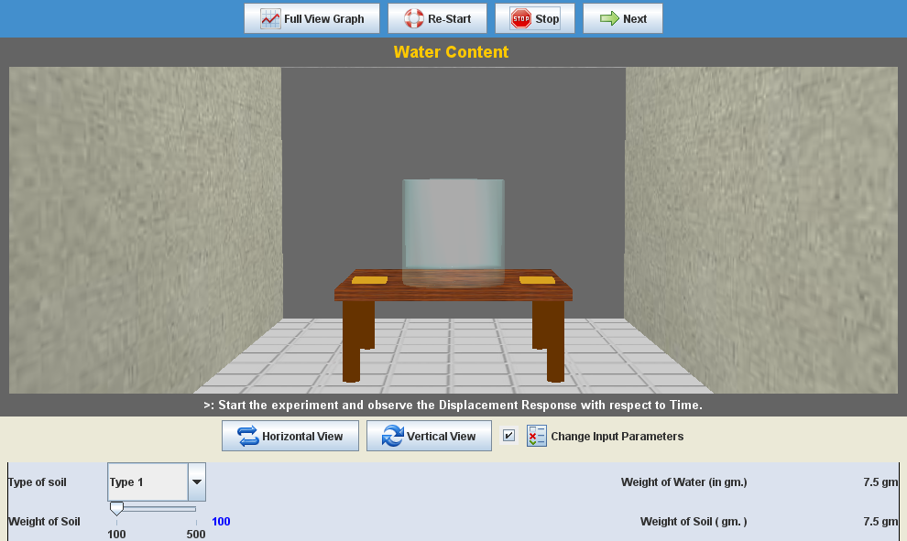
-----------------------------------------------YET TO DO ------------------------------------------------

LABORATORY ROOM CONSISTS:
- Table

INPUT:
- Type of Soil

OUTPUT:
- Water Limit
- Plastic Limit

